MNIST Tanh:

Not normalized (images in 0-255):

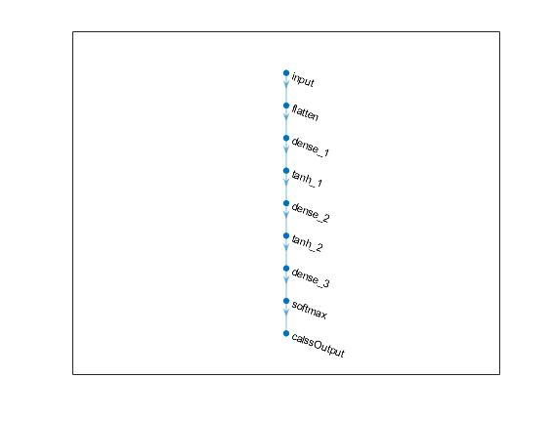

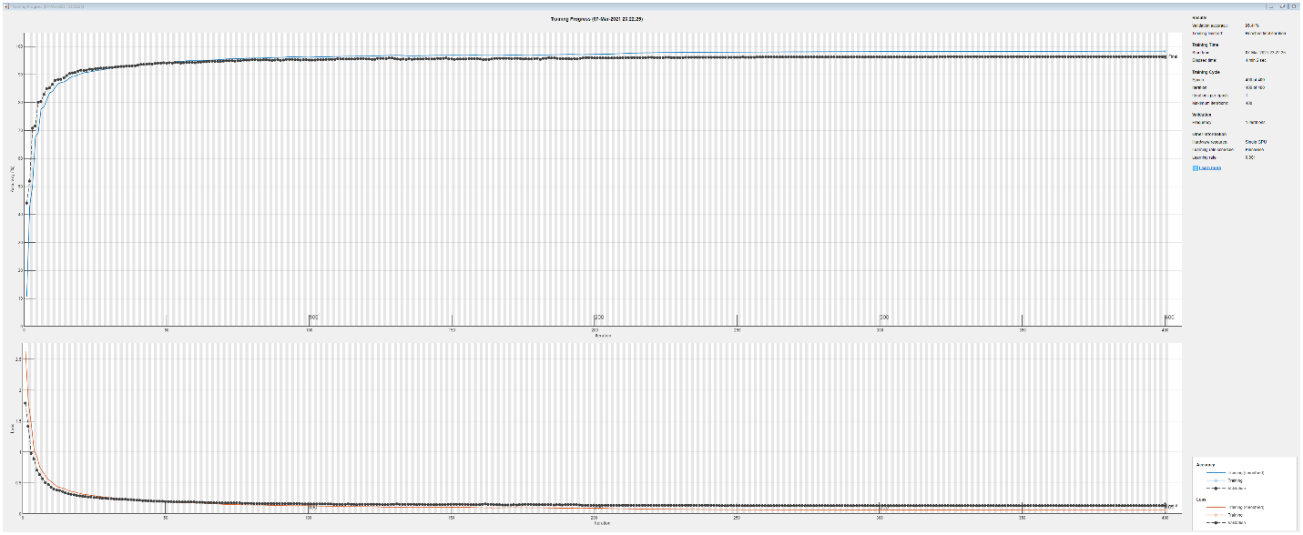

Validation accuracy: 96.41%

Test accuracy = 95.65%

MNIST Tanh:

Normalized (images in 0-1):



Validation accuracy:

Test accuracy =